UNIT-IV
Chapter-1
PROCESS & PRODUCT METRICS

Introduction: Software Quality, Metrics for Analysis Model, Metrics for Design Model, Metrics for source code, Metrics for testing, Metrics for maintenance. Metrics for Process and Products : Software Measurement, Metrics for software quality. Testing Strategies: A strategic approach to software testing, test strategies for conventional software, Black-Box and White-Box testing, Validation testing, System testing, the art of Debugging.

1. Software Quality:
1.1 Software Quality Fundamentals
Commitment to Software Quality as part of organization culture. The notion of “quality” is difficult. Identification of quality characteristics attributes and targets. Quality cost, Modeling Software Quality, Process and Product quality It is difficult (may be, not entirely possible) to distinguish process quality from product quality.

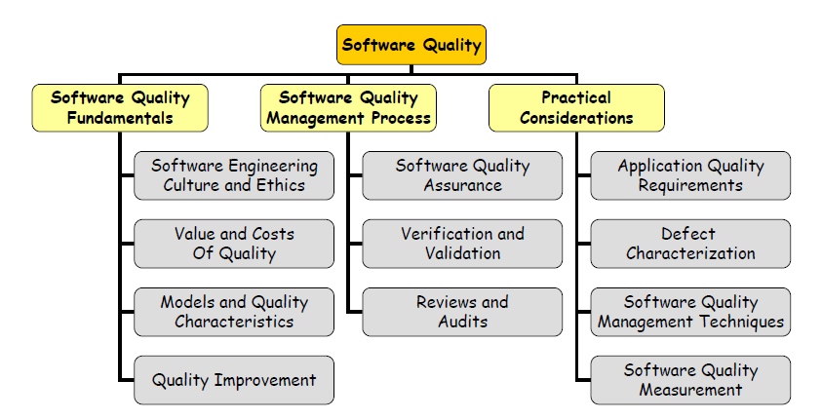
Process and Product Quality

A fundamental assumption of quality management is that the quality of the development process directly affects the quality of the delivered products. The link between software process qualities And software product quality is complex. Process quality management involves Defining process standards such as how and when reviews should be conducted, Monitoring the development process to ensure that the standards are being followed , Reporting the software process to project management and to the buyer of the software Software Quality Management Processes Planning software quality involves defining the required product in terms of its quality (internal and external) characteristics Planning the processes to achieve the required product, Characteristics that govern how the product works in its environment are called external, which include, for example, usability and reliability, Characteristic related to how the product was developed are called internal quality Characteristics, and include, for example, structural complexity, size, test coverage, and fault Rates Software Quality Management Processes, Quality assurance process: ensuring that the software products and processes in the project life cycle conform to their specified requirements by planning, enacting, and performing a set of activities to provide adequate confidence that the quality is being built into the software , Verification and validation processes: assessing software products throughout the product lifecycle , Review and audit processes: involving Management reviews, Technical reviews, Inspections, Walkthrough and Audits.

1.2 Quality Planning
Quality planning is the process of developing a quality plan for the project. A quality plan involves Product introduction: A description of the product, its intended market and the quality expectation for the product.
Product plans: The critical release dates and responsibilities for the product along with plans for distribution and product servicing.
Process descriptions: the development and service processes that should be used for product development and management.
Quality Goals: The quality goals and plans for the product including an identification and justification of critical product quality attributes
Risks and risk management: The key risks that might affect product quality and the actions to address these risks
1.3 Quality Assurance and Standards
Quality assurance is the process of defining how software quality can be achieved and how the development organization knows that the software has the required level of quality. Quality assurance standards, Product standards and Software standards are based on knowledge (“best-practice” or “state-of-the-art”) Provide a framework for implementing a quality assurance process Assist/support continuity in practice within an organization Issues: Software engineers sometimes dislike standards Need to involve software engineering in the selection of standards Review and modify standards regularly to reflect changing technologies Provide software tools to support standards where possible

Even the most jaded software developers will agree that high-quality software is an important goal. But how do we define quality? In Chapter 8, we proposed a number of different ways to look at software quality and introduced a definition that stressed conformance to explicitly stated functional and performance requirements, explicitly documented development standards, and implicit characteristics that are expected of all professionally developed software. There is little question that the preceding definition could be modified or extended and debated endlessly. For the purposes of this book, the definition serves to emphasize three important points:

1. Software requirements are the foundation from which quality is measured. Lack of conformance to requirements is lack of quality.

2. Specified standards define a set of development criteria that guide the manner in which software is engineered. If the criteria are not followed, lack of quality will almost surely result.

3. There is a set of implicit requirements that often goes unmentioned (e.g., the desire for ease of use). If software conforms to its explicit requirements but fails to meet implicit requirements, software quality is suspect.

Software quality is a complex mix of factors that will vary across different applications and the customers who request them. In the sections that follow, software quality factors are identified and the human activities required to achieve them are described.
1.2 McCall’s Quality Factors
The factors that affect software quality can be categorized in two broad groups: (1) factors that can be directly measured (e.g., defects per function-point) and (2) factors that can be measured only indirectly (e.g., usability or maintainability). In each case measurement must occur. We must compare the software (documents, programs, data) to some datum and arrive at an indication of quality.
McCall, Richards, and Walters [MCC77] propose a useful categorization of factors that affect software quality. These software quality factors, shown in below Figure, focus on three important aspects of a software product: its operational characteristics, its ability to undergo change, and its adaptability to new environments. Referring to the factors noted in Figure 19.1, McCall and his colleagues provide the following descriptions:
Correctness. The extent to which a program satisfies its specification and fulfills the customer's mission objectives.
Reliability. The extent to which a program can be expected to perform its intended function with required precision. [It should be noted that other, more complete definitions of reliability have been proposed
Efficiency. The amount of computing resources and code required by a program to perform its function.
Integrity. Extent to which access to software or data by unauthorized persons can be controlled. Usability. Effort required learning, operating, preparing input, and interpreting output of a program.
Maintainability. Effort required locating and fixing an error in a program. [This is a very limited definition.]
Flexibility. Effort required modifying an operational program
Testability. Effort required testing a program to ensure that it performs its intended function.
Portability. Effort required transferring the program from one hardware and/or software system environment to another.
Reusability. Extent to which a program [or parts of a program] can be reused in other applications—related to the packaging and scope of the functions that the program performs.
Interoperability. Effort required to couple one system to another.
It is difficult, and in some cases impossible, to develop direct measures of these quality factors. Therefore, a set of metrics are defined and used to develop expressions for each of the factors according to the following relationship:
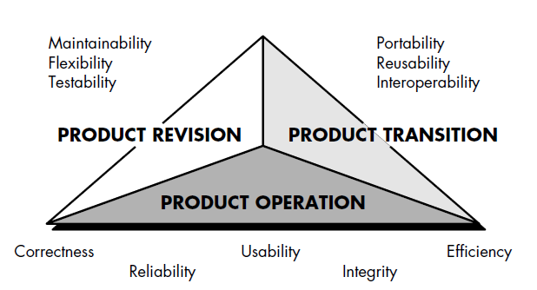
Fq = c1 _ m1 + c2 _ m2 + . . . + cn _ mn
where Fq is a software quality factor, cn are regression coefficients, mn are the metrics that affect the quality factor. Unfortunately, many of the metrics defined by McCall et al. can be measured only subjectively. The metrics may be in the form of a checklist that is used to "grade" specific attributes of the software [CAV78]. The grading scheme proposed by McCall et al. is a 0 (low) to 10 (high) scale.

1.3 FURPS
The quality factors described by McCall and his colleagues [MCC77] represent one of a number of suggested “checklists” for software quality. Hewlett-Packard [GRA87] developed a set of software quality factors that has been given the acronym FURPS— functionality, usability, reliability, performance, and supportability. The FURPS quality factors draw liberally from earlier work, defining the following attributes for each of the five major factors:
• Functionality is assessed by evaluating the feature set and capabilities of the program, the generality of the functions that are delivered, and the security of the overall system.
• Usability is assessed by considering human factors, overall aesthetics, consistency, and documentation.
• Reliability is evaluated by measuring the frequency and severity of failure, the accuracy of output results, the mean-time-to-failure (MTTF), the ability to recover from failure, and the predictability of the program.
• Performance is measured by processing speed, response time, resource consumption, throughput, and efficiency.

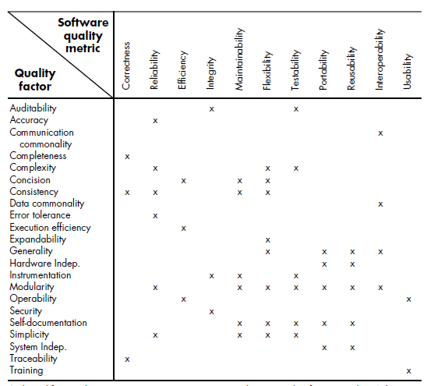
Supportability combines the ability to extend the program (extensibility), adaptability, serviceability—these three attributes represent a more common term, maintainability—in addition, testability, compatibility, configurability (the ability to organize and control elements of the software configuration,, the ease with which a system can be installed, and the ease with which problems can be localized.The FURPS quality factors and attributes just described can be used to establish quality metrics for each step in the software engineering process.

1.4 ISO 9126 Quality Factors
The ISO 9126 standard was developed in an attempt to identify the key quality attributes for computer software. The standard identifies six key quality attributes:
Functionality: The degree to which the software satisfies stated needs as indicated by the following subattributes: suitability, accuracy, interoperability, compliance, and security.
Reliability: The amount of time that the software is available for use as indicated by the following subattributes: maturity, fault tolerance, recoverability.
Usability: The degree to which the software is easy to use as indicated by the following sub attributes: understandability, learnability, operability.
Efficiency: The degree to which the software makes optimal use of system resources as indicated by the following sub attributes: time behavior, resource behavior.
Maintainability: The ease with which repair may be made to the software as indicated by the following sub attributes: analyzability, changeability, stability, testability.
Portability: The ease with which the software can be transposed from one environment to another as indicated by the following sub attributes: adaptability, installability, conformance, replaceability. Like other software quality factors discussed above the ISO 9126 factors do not necessarily lend themselves to direct measurement. However, they do provide a worthwhile basis for indirect measures and an excellent checklist for assessing the quality of a system. The Transition to a Quantitative View In the preceding sections, a set of qualitative factors for the "measurement" of software quality was discussed. We strive to develop precise measures for software quality and are sometimes frustrated by the subjective nature of the activity. Cavano and McCall [CAV78] discuss this situation:
The determination of quality is a key factor in every day events—wine tasting contests, sporting events [e.g., gymnastics], talent contests, etc. In these situations, quality is judged in the most fundamental and direct manner: side by side comparison of objects under identical conditions and with predetermined concepts. The wine may be judged according to clarity, color, bouquet, taste, etc. However, this type of judgment is very subjective; to have any value at all, it must be made by an expert. Subjectivity and specialization also apply to determining software quality. To help solve this problem, a more precise definition of software quality is needed as well as a way to derive quantitative measurements of software quality for objective analysis . . . Since there is no such thing as absolute knowledge, one should not expect to measure software quality exactly, for every measurement is partially imperfect. Jacob Bronkowski described this paradox of knowledge in this way: "Year by year we devise more precise instruments with which to observe nature with more fineness. And when we look at the observations we are discomfited to see that they are still fuzzy, and we feel that they are as uncertain as ever." In the sections that follow, we examine a set of software metrics that can be applied to the quantitative assessment of software quality. In all cases, the metrics represent indirect measures; that is, we never really measure quality but rather some manifestation of quality. The complicating factor is the precise relationship between the variable that is measured and the quality of software.

1.5 Framework For Technical Software Metrics
As we noted in the introduction to this chapter, measurement assigns numbers or symbols to attributes of entities in the real word. To accomplish this, a measurement model encompassing a consistent set of rules is required. Although the theory of measurement (e.g., [KYB84]) and its application to computer software (e.g., [DEM81], [BRI96], [ZUS97]) are topics that are beyond the scope of this book, it is worthwhile to establish a fundamental framework and a set of basic principles for the measurement of technical metrics for software.

1.5.1 The Challenge of Technical Metrics
Over the past three decades, many researchers have attempted to develop a single metric that provides a comprehensive measure of software complexity. Fenton [FEN94] characterizes this research as a search for “the impossible holy grail.” Although dozens of complexity measures have been proposed [ZUS90], each takes a somewhat different view of what complexity is and what attributes of a system lead to complexity. By analogy, consider a metric for evaluating an attractive car. Some observers might emphasize body design, others might consider mechanical characteristics, still others might tout cost, or performance, or fuel economy, or the ability to recycle when the car is junked. Since any one of these characteristics may be at odds with others, it is difficult to derive a single value for “attractiveness.” The same problem occurs with computer software. Yet there is a need to measure and control software complexity. And if a single value of this quality metric is difficult to derive, it should be possible to develop measures of different internal program attributes (e.g., effective modularity, functional independence, and other attributes discussed in Chapters 13 through 16). These measures and the metrics derived from them can be used as independent indicators of the quality of analysis and design models. But here again, problems arise. Fenton [FEN94] notes this when he states:
The danger of attempting to find measures which characterize so many different attributes is that inevitably the measures have to satisfy conflicting aims. This is counter to the representational theory of measurement. Although Fenton’s statement is correct, many people argue that technical measurement conducted during the early stages of the software process provides software engineers with a consistent and objective mechanism for assessing quality. It is fair to ask, however, just how valid technical metrics are. That is, how closely aligned are technical metrics to the long-term reliability and quality of a computer based system? Fenton [FEN91] addresses this question in the following way:
In spite of the intuitive connections between the internal structure of software products [technical metrics] and its external product and process attributes, there have actually been very few scientific attempts to establish specific relationships. There are a number of reasons why this is so; the most commonly cited is the impracticality of conducting relevant experiments. Each of the “challenges” noted here is a cause for caution, but it is no reason to dismiss technical metrics.2 Measurement is essential if quality is to be achieved

1.6 Metrics for the Analysis Model

Technical work in software engineering begins with the creation of the analysis model. It is at this stage that requirements are derived and that a foundation for design is established. Therefore, technical metrics that provide insight into the quality of the analysis model are desirable.
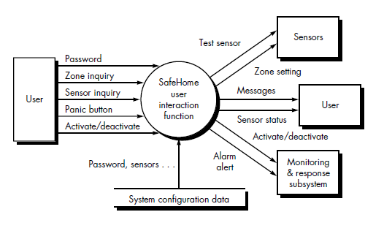
Although relatively few analysis and specification metrics have appeared in the literature, it is possible to adapt metrics derived for project application for use in this context. These metrics examine the analysis model with the intent of predicting the “size” of the resultant system. It is likely that size and design complexity will be directly correlated.

1.6.1 Function-Based Metrics
The function point metric can be used effectively as a means for predicting the size of a system that will be derived from the analysis model. To illustrate the use of the FP metric in this context, we consider a simple analysis model representation, illustrated in Figure Referring to the figure, a data flow diagram for a function within the SafeHome software4 is represented. The function manages user interaction, accepting a user password to activate or deactivate the system, and allows inquiries on the status of security zones and various security sensors. The function displays a series of prompting messages and sends appropriate control signals to various components of the security system. The data flow diagram is evaluated to determine the key measures required for computation of the function point metric
- number of user inputs
- number of user outputs
- number of user inquiries
- number of files
- number of external interfaces
Three user inputs—password, panic button, and activate/deactivate—are shown in the figure along with two inquires—zone inquiry and sensor inquiry. One file (system configuration file) is shown. Two user outputs (messages and sensor status) and four external interfaces (test sensor, zone setting, activate/deactivate, and alarm alert) are also present. These data, along with the appropriate complexity, are shown in Figure. The count total shown in Figure must be adjusted using Equation (4-1):
FP = count total _ [0.65 + 0.01 _ _ (Fi)]
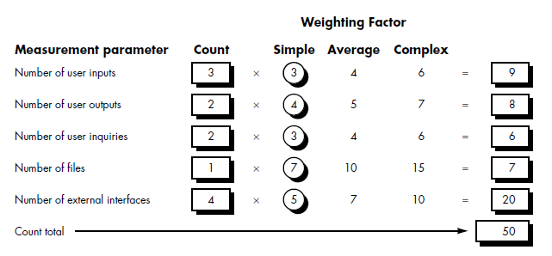

where count total is the sum of all FP entries obtained from Figure 19.3 and Fi (i = 1 to 14) are "complexity adjustment values." For the purposes of this example, we assume that _ (Fi) is 46 (a moderately complex product). Therefore, FP = 50 _ [0.65 + (0.01 _ 46)] = 56 Based on the projected FP value derived from the analysis model, the project team can estimate the overall implemented size of the SafeHome user interaction function. Assume that past data indicates that one FP translates into 60 lines of code (an object-oriented language is to be used) and that 12 FPs are produced for each person-month of effort. These historical data provide the project manager with important planning information that is based on the analysis model rather than preliminary estimates. Assume further that past projects have found an average of three errors per function point during analysis and design reviews and four errors per function point during unit and integration testing. These data can help software engineers assess the completeness of their review and testing activities.

1.6.2 Metrics for Specification Quality
Davis and his colleagues [DAV93] propose a list of characteristics that can be used to assess the quality of the analysis model and the corresponding requirements specification: specificity (lack of ambiguity), completeness, correctness, understandability, verifiability, internal and external consistency, achievability, concision, traceability, modifiability, precision, and reusability. In addition, the authors note that high-quality specifications are electronically stored, executable or at least interpretable, annotated by relative importance and stable, versioned, organized, cross-referenced, and specified at the right level of detail. Although many of these characteristics appear to be qualitative in nature, Davis et al. [DAV93] suggest that each can be represented using one or more metrics.6 For example, we assume that there are nr requirements in a specification, such that nr = nf + nnf where nf is the number of functional requirements and nnf is the number of nonfunctional (e.g., performance) requirements. To determine the specificity (lack of ambiguity) of requirements, Davis et al. suggest a metric that is based on the consistency of the reviewers’ interpretation of each requirement: Q1 = nui/n
where nui is the number of requirements for which all reviewers had identical interpretations. The closer the value of Q to 1, the lower is the ambiguity of the specification. The completeness of functional requirements can be determined by computing the ratio Q2 = nu/[ni _ ns] where nu is the number of unique function requirements, ni is the number of inputs (stimuli) defined or implied by the specification, and ns is the number of states specified. The Q2 ratio measures the percentage of necessary functions that have been specified for a system. However, it does not address nonfunctional requirements. To incorporate these into an overall metric for completeness, we must consider the degree to which requirements have been validated: Q3 = nc/[nc + nnv] where nc is the number of requirements that have been validated as correct and nnv
is the number of requirements that have not yet been validated.

1.6.4 Metrics for the Design Model
It is inconceivable that the design of a new aircraft, a new computer chip, or a new office building would be conducted without defining design measures, determining metrics for various aspects of design quality, and using them to guide the manner in which the design evolves. And yet, the design of complex software-based systems often proceeds with virtually no measurement. The irony of this is that design metrics for software are available, but the vast majority of software engineers continue to be unaware of their existence. Design metrics for computer software, like all other software metrics, are not perfect. Debate continues over their efficacy and the manner in which they should be applied. Many experts argue that further experimentation is required before design measures can be used. And yet, design without measurement is an unacceptable alternative.
In the sections that follow, we examine some of the more common design metrics for computer software. Each can provide the designer with improved insight and all can help the design to evolve to a higher level of quality. Architectural Design Metrics Architectural design metrics focus on characteristics of the program architecture with an emphasis on the architectural structure and the effectiveness of modules. These metrics are black box in the sense that they do not require any knowledge of the inner workings of a particular software component.

Card and Glass [CAR90] define three software design complexity measures: structural complexity, data complexity, and system complexity. Structural complexity of a module i is defined in the following manner: S(i) = f 2 out(i) (19-1)
where fout(i) is the fan-out7 of module i. Data complexity provides an indication of the complexity in the internal interface for a module i and is defined as D(i) = v(i)/[ fout(i) +1] (19-2) where v(i) is the number of input and output variables that are passed to and from module i. Finally, system complexity is defined as the sum of structural and data complexity, specified as C(i) = S(i) + D(i) (19-3) As each of these complexity values increases, the overall architectural complexity of the system also increases. This leads to a greater likelihood that integration and testing effort will also increase.
An earlier high-level architectural design metric proposed by Henry and Kafura [HEN81] also makes use the fan-in and fan-out. The authors define a complexity metric (applicable to call and return architectures) of the form HKM = length(i) _ [ fin(i) + fout(i)]2 (19-4) where length(i) is the number of programming language statements in a module I and fin(i) is the fan-in of a module i. Henry and Kafura extend the definitions of fanin and fan-out presented in this book to include not only the number of module control connections (module calls) but also the number of data structures from which a module i retrieves (fan-in) or updates (fan-out) data. To compute HKM during design, the procedural design may be used to estimate the number of programming language statements for module i. Like the Card and Glass metrics noted previously, an increase in the Henry-Kafura metric leads to a greater likelihood that integration and testing effort will also increase for a module. Fenton [FEN91] suggests a number of simple morphology (i.e., shape) metrics that enable different program architectures to be compared using a set of straightforward dimensions. Referring to Figure 19.5, the following metrics can be defined:
size = n + a where n is the number of nodes and a is the number of arcs. For the architecture shown in Figure 19.5, size = 17 + 18 = 35 depth = the longest path from the root (top) node to a leaf node. For the architecture shown in Figure 19.5, depth = 4. width = maximum number of nodes at any one level of the architecture. For the architecture shown in Figure 19.5, width = 6.
arc-to-node ratio, r = a/n, which measures the connectivity density of the architecture and may provide a simple indication of the coupling of the architecture.
For the architecture shown in Figure
19.5, r = 18/17 = 1.06.

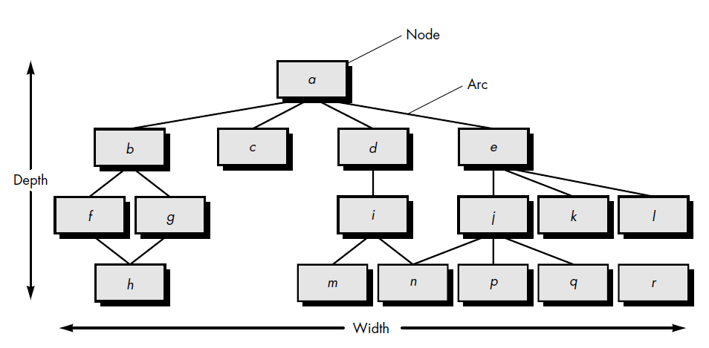
The U.S. Air Force Systems Command [USA87] has developed a number of software quality indicators that are based on measurable design characteristics of a computer program. Using concepts similar to those proposed in IEEE Std. 982.1-1988 [IEE94], the Air Force uses information obtained from data and architectural design to derive a design structure quality index (DSQI) that ranges from 0 to 1. The following values must be ascertained to compute the DSQI [CHA89]: S1 = the total number of modules defined in the program architecture. S2 = the number of modules whose correct function depends on the source of data input or that produce data to be used elsewhere (in general, control modules, among others, would not be counted as part of S2).S3 = the number of modules whose correct function depends on prior processing.
S4 = the number of database items (includes data objects and all attributes that define objects). S5 = the total number of unique database items. S6 = the number of database segments (different records or individual objects). S7 = the number of modules with a single entry and exit exception processing is not considered to be a multiple exit). Once values S1 through S7 are determined for a computer program, the following intermediate values can be computed:
Program structure: D1, where D1 is defined as follows: If the architectural design was eveloped using a distinct method (e.g., data flow-oriented design or object-oriented design), then D1 = 1, otherwise D1 = 0.
Module independence: D2 = 1 _ (S2/S1)
Modules not dependent on prior processing: D3 = 1 _ (S3/S1)
Database size: D4 = 1 _ (S5/S4)
Database compartmentalization: D5 = 1 _ (S6/S4)
Module entrance/exit characteristic: D6 = 1 _ (S7/S1)
With these intermediate values determined, the DSQI is computed in the following manner:
DSQI = _ wiDi (19-5)
where i = 1 to 6, wi is the relative weighting of the importance of each of the intermediate values, and _ wi = 1 (if all Di are weighted equally, then wi = 0.167). The value of DSQI for past designs can be determined and compared to a design that is currently under development. If the DSQI is significantly lower than average, further design work and review are indicated. Similarly, if major changes are to be made to an existing design, the effect of those changes on DSQI can be calculated.

1.6.6 Metrics for Source Code
Halstead's theory of software science [HAL77] is one of "the best known and most thoroughly studied . . . composite measures of (software) complexity" [CUR80]. Software science proposed the first analytical "laws" for computer software.9 Software science assigns quantitative laws to the development of computer software, using a set of primitive measures that may be derived after code is generated or estimated once design is complete. These follow:
n1 = the number of distinct operators that appear in a program.
n2 = the number of distinct operands that appear in a program.
N1 = the total number of operator occurrences.
N2 = the total number of operand occurrences.
Halstead uses these primitive measures to develop expressions for the overall program length, potential minimum volume for an algorithm, the actual volume (number of bits required to specify a program), the program level (a measure of software complexity), the language level (a constant for a given language), and other features such as development effort, development time, and even the projected number of faults in the software. Halstead shows that length N can be estimated N = n1 log 2 n1 + n2 log 2 n2 (19-10) and program volume may be defined
V = N log 2 (n1 + n2) (19-11) It should be noted that V will vary with programming language and represents the volume of information (in bits) required to specify a program. Theoretically, a minimum volume must exist for a particular algorithm. Halstead defines a volume ratio L as the ratio of volume of the most compact form of a program to the volume of the actual program. In actuality, L must always be less than 1. In terms of primitive measures, the volume ratio may be expressed as L = 2/n1 _ n2/N2 (19-12) Halstead's work is amenable to experimental verification and a large body of research has been conducted to investigate software science. A discussion of this work is beyond the scope of this text, but it can be said that good agreement has been found between analytically predicted and experimental results. For further information, see [ZUS90], [FEN91], and [ZUS97].

1.6.7 Metrics for Testing
Although much has been written on software metrics for testing (e.g., [HET93]), the majority of metrics proposed focus on the process of testing, not the technical characteristics of the tests themselves. In general, testers must rely on analysis, design, and code metrics to guide them in the design and execution of test cases. Function-based metrics (Section 19.3.1) can be used as a predictor for overall testing effort. Various project-level characteristics (e.g., testing effort and time, errors uncovered, number of test cases produced) for past projects can be collected and correlated with the number of FP produced by a project team. The team can then project “expected values” of these characteristics for the current project. The bang metric can provide an indication of the number of test cases required by examining the primitive measures discussed in Section 19.3.2. The number of functional primitives (FuP), data elements (DE), objects (OB), relationships (RE), states (ST), and transitions (TR) can be used to project the number and types of black-box and white-box tests for the software. For example, the number of tests associated with the human/computer interface can be estimated by (1) examining the number of transitions (TR) contained in the state transition representation of the HCI and evaluating the tests required to exercise each transition; (2) examining the number of data objects (OB) that move across the interface, and (3) the number of data elements that are input or output. Architectural design metrics provide information on the ease or difficulty associated with integration testing (Chapter 18) and the need for specialized testing software (e.g., stubs and drivers). Cyclomatic complexity (a component-level design metric) lies at the core of basis path testing, a test case design method presented. In addition, cyclomatic complexity can be used to target modules as candidates for xtensive unit testing (Chapter 18). Modules with high cyclomatic complexity are more likely to be error prone than modules whose cyclomatic complexity is lower. For this reason, the tester should expend above average effort to uncover errors in such modules before they are integrated in a system. Testing effort can also be estimated using metrics derived from Halstead measures (Section 19.5). Using the definitions for program volume, V, and program level, PL, software science effort, e, can be computed as PL = 1/[(n1/2)•(N2/n2
e = V/PL
The percentage of overall testing effort to be allocated to a module k can be estimated using the following relationship:
percentage of testing effort (k) = e(k)/ _ e(i)
where e(k) is computed for module k using Equations (19-13) and the summation in the denominator of Equation (19-14) is the sum of software science effort across all modules of the system. As tests are conducted, three different measures provide an indication of testing completeness. A measure of the breath of testing provides an indication of how many requirements (of the total number of requirements) have been tested. This provides an indication of the completeness of the test plan. Depth of testing is a measure of the percentage of independent basis paths covered by testing versus the total number of basis paths in the program. A reasonably accurate estimate of the number of basis paths can be computed by adding the cyclomatic complexity of all program modules. Finally, as tests are conducted and error data are collected, fault profiles may be used to rank and categorize errors uncovered. Priority indicates the severity of the problem. Fault categories provide a description of an error so that statistical
error analysis can be conducted.

1.6.8 Metrics for Maintenance
All of the software metrics introduced in this chapter can be used for the development of new software and the maintenance of existing software. However, metrics designed explicitly for maintenance activities have been proposed. IEEE Std. 982.1-1988 [IEE94] suggests a software maturity index (SMI) that provides an indication of the stability of a software product (based on changes that occur for each release of the product). The following information is determined:
MT = the number of modules in the current release
Fc = the number of modules in the current release that have been changed
Fa = the number of modules in the current release that have been added
Fd = the number of modules from the preceding release that were deleted in the current release
The software maturity index is computed in the following manner:
SMI = [MT _ (Fa + Fc + Fd)]/MT (19-15)
As SMI approaches 1.0, the product begins to stabilize. SMI may also be used as metric for planning software maintenance activities. The mean time to produce a release of a software product can be correlated with SMI and empirical models for maintenance effort can be developed.

1.7 Metrics for Process and Products
1.7.1 Measures, Metrics, and Indicators
Although the terms measure, measurement, and metrics are often used interchangeably, it is important to note the subtle differences between them. Because measure can be used either as a noun or a verb, definitions of the term can become confusing. Within the software engineering context, a measure provides a quantitative indication of the extent, amount, dimension, capacity, or size of some attribute of a product or process. Measurement is the act of determining a measure. The IEEE Standard Glossary of Software Engineering Terms [IEE93] defines metric as “a quantitative measure of the degree to which a system, component, or process possesses a given attribute.” When a single data point has been collected (e.g., the number of errors uncovered in the review of a single module), a measure has been established. Measurement occurs as the result of the collection of one or more data points (e.g., a number of module reviews are investigated to collect measures of the number of errors for each). A software metric relates the individual measures in some way (e.g., the average number of errors found per review or the average number of errors found per person- hour expended on reviews.1 A software engineer collects measures and develops metrics so that indicators will be obtained. An indicator is a metric or combination of metrics that provide insight into the software process, a software project, or the product itself [RAG95]. An indicator provides insight that enables the project manager or software engineers to adjust the process, the project, or the process to make things better. For example, four software teams are working on a large software project. Each team must conduct design reviews but is allowed to select the type of review that it will use. Upon examination of the metric, errors found per person-hour expended, the project manager notices that the two teams using more formal review methods exhibit an errors found per person-hour expended that is 40 percent higher than the other teams. Assuming all other parameters equal, this provides the project manager with an indicator that formal review methods may provide a higher return on time investment than another, less formal review approach. She may decide to suggest that all teams use the more formal approach. The metric provides the manager with insight. And insight leads to informed decision making.
1.7.2 Software Measurement
Measurements in the physical world can be categorized in two ways: direct measures (e.g., the length of a bolt) and indirect measures (e.g., the "quality" of bolts produced, measured by counting rejects). Software metrics can be categorized similarly. Direct measures of the software engineering process include cost and effort applied. Direct measures of the product include lines of code (LOC) produced, execution speed, memory size, and defects reported over some set period of time.
Indirect measures of the product include functionality, quality, complexity, efficiency, reliability, maintainability, and many other "–abilities" that are discussed. The cost and effort required to build software, the number of lines of code produced, and other direct measures are relatively easy to collect, as long as specific conventions for measurement are established in advance. However, the quality and functionality of software or its efficiency or maintainability are more difficult to assess and can be measured only indirectly. We have already partitioned the software metrics domain into process, project, and product metrics. We have also noted that product metrics that are private to an individual are often combined to develop project metrics that are public to a software team. Project metrics are then consolidated to create process metrics that are public to the software organization as a whole. But how does an organization combine metrics that come from different individuals or projects? To illustrate, we consider a simple example. Individuals on two different project teams record and categorize all errors that they find during the software process. Individual measures are then combined to develop team measures. Team A found 342 errors during the software process prior to release. Team B found 184 errors. All other things being equal, which team is more effective in uncovering errors throughout the process? Because we do not know the size or complexity of the projects, we cannot answer this question. However, if the measures are normalized, it is possible to create software metrics that enable comparison to broader organizational averages.

1.7.3 Size-Oriented Metrics
Size-oriented software metrics are derived by normalizing quality and/or productivity measures by considering the size of the software that has been produced. If a software organization maintains simple records, a table of size-oriented measures, such as the one shown in Figure 4.4, can be created. The table lists each software development project that has been completed over the past few years and corresponding measures for that project. Referring to the table entry for project alpha: 12,100 lines of code were developed with 24 person-months of effort at a cost of $168,000. It should be noted that the effort and cost recorded in the table represent all software engineering activities (analysis, design, code, and test), not just coding. Further information for project alpha indicates that 365 pages of documentation were developed, 134 errors were recorded before the software was released, and 29 defects were encountered after release to the customer within the first year of operation. Three people worked on the development of software for project alpha. In order to develop metrics that can be assimilated with similar metrics from other projects, we choose lines of code as our normalization value. From the rudimentary data contained in the table, a set of simple size-oriented metrics can be developed for each project: • Errors per KLOC (thousand lines of code).
• Defects4 per KLOC.
• $ per LOC.
• Page of documentation per KLOC. In addition, other interesting metrics can be computed:
• Errors per person-month.
• LOC per person-month.
• $ per page of documentation.
Size-oriented metrics are not universally accepted as the best way to measure the process of software development [JON86]. Most of the controversy swirls around the use of lines of code as a key measure. Proponents of the LOC measure claim that LOC is an "artifact" of all software development projects that can be easily counted, that many existing software estimation models use LOC or KLOC as a key input, and that a large body of literature and data predicated on LOC already exists. On the other hand, opponents argue that LOC measures are programming anguage dependent, that they penalize well-designed but shorter programs, that they cannot easily accommodate nonprocedural languages, and that their use in estimation requires a level of detail that may be difficult to achieve (i.e., the planner must estimate the LOC to be produced long before analysis and design have been completed).

1.8 Metrics for Software Quality
The overriding goal of software engineering is to produce a high-quality system, application, or product. To achieve this goal, software engineers must apply effective methods coupled with modern tools within the context of a mature software process. In addition, a good software engineer (and good software engineering managers) must measure if high quality is to be realized.
The quality of a system, application, or product is only as good as the requirements that describe the problem, the design that models the solution, the code that leads to an executable program, and the tests that exercise the software to uncover errors. A good software engineer uses measurement to assess the quality of the analysis and design models, the source code, and the test cases that have been created as the software is engineered. To accomplish this real-time quality assessment, the engineer must use technical measures to evaluate quality in objective, rather than subjective ways.
The project manager must also evaluate quality as the project progresses. Private metrics collected by individual software engineers are assimilated to provide project-level results. Although many quality measures can be collected, the primary thrust at the project level is to measure errors and defects. Metrics derived from these measures provide an indication of the effectiveness of individual and group software quality assurance and control activities.
Metrics such as work product (e.g., requirements or design) errors per function point, errors uncovered per review hour, and errors uncovered per testing hour provide insight into the efficacy of each of the activities implied by the metric. Error data can also be used to compute the defect removal efficiency (DRE) for each process framework activity. DRE is discussed in Section 4.5.3.

1.9 An Overview of Factors That Affect Quality
Over 25 years ago, McCall and Cavano [MCC78] defined a set of quality factors that were a first step toward the development of metrics for software quality. These factors assess software from three distinct points of view: (1) product operation (using it), (2) product revision (changing it), and (3) product transition (modifying it to work in a different environment; i.e., "porting" it). In their work, the authors describe the relationship between these quality factors (what they call a framework) and other aspects of the software engineering process:
First, the framework provides a mechanism for the project manager to identify what qualities are important. These qualities are attributes of the software in addition to its functional correctness and performance which have life cycle implications. Such factors as maintainability and portability have been shown in recent years to have significant life cycle cost impact . . .
Secondly, the framework provides a means for quantitatively assessing how well the development is progressing relative to the quality goals established . . .
Thirdly, the framework provides for more interaction of QA personnel throughout the development effort . . .
Lastly, . . . quality assurance personal can use indications of poor quality to help identify [better] standards to be enforced in the future.
A detailed discussion of McCall and Cavano's framework, as well as other quality factors, is presented in above section. It is interesting to note that nearly every aspect of computing has undergone radical change as the years have passed since McCall and Cavano did their seminal work in 1978. But the attributes that provide an indication of software quality remain the same.
What does this mean? If a software organization adopts a set of quality factors as a "checklist" for assessing software quality, it is likely that software built today will still exhibit quality well into the first few decades of this century. Even as computing architectures undergo radical change (as they surely will), software that exhibits high quality in operation, transition, and revision will continue to serve its users well.

1.10 Measuring Quality
Although there are many measures of software quality, correctness, maintainability, integrity, and usability provide useful indicators for the project team. Gilb [GIL88] suggests definitions and measures for each.
Correctness. A program must operate correctly or it provides little value to its users. Correctness is the degree to which the software performs its required function. The most common measure for correctness is defects per KLOC, where a defect is defined as a verified lack of conformance to requirements. When considering the overall quality of a software product, defects are those problems reported by a user of the program after the program has been released for general use. For quality assessment purposes, defects are counted over a standard period of time, typically one year.
Maintainability. Software maintenance accounts for more effort than any other software engineering activity. Maintainability is the ease with which a program can be corrected if an error is encountered, adapted if its environment changes, or enhanced if the customer desires a change in require-ments. There is no way to measure maintainability directly; therefore, we must use indirect measures. A simple time-oriented metric is mean-time-to-change (MTTC), the time it takes to analyze the change request, design an appropriate modification, implement the change, test it, and distribute the change to all users. On average, programs that are maintainable will have a lower MTTC (for equivalent types of changes) than programs that are not maintainable.
Hitachi [TAJ81] has used a cost-oriented metric for maintainability called spoilage—the cost to correct defects encountered after the software has been released to its end-users. When the ratio of spoilage to overall project cost (for many projects) is plotted as a function of time, a manager can determine whether the overall maintainability of software produced by a software development organization is improving. Actions can then be taken in response to the insight gained from this information.
Integrity. Software integrity has become increasingly important in the age of hackers and firewalls. This attribute measures a system's ability to withstand attacks (both accidental and intentional) to its security. Attacks can be made on all three components of software: programs, data, and documents.
To measure integrity, two additional attributes must be defined: threat and security. Threat is the probability (which can be estimated or derived from empirical evidence) that an attack of a specific type will occur within a given time. Securityis the probability (which can be estimated or derived from empirical evidence) that the attack of a specific type will be repelled. The integrity of a system can then be defined as
integrity = summation [(1 - threat) x (1 - security)]
where threat and security are summed over each type of attack.
Usability. The catch phrase "user-friendliness" has become ubiquitous in discussions of software products. If a program is not user-friendly, it is often doomed to failure, even if the functions that it performs are valuable. Usability is an attempt to quantify user-friendliness and can be measured in terms of four characteristics:
(1) the physical and or intellectual skill required to learn the system, (2) the time required to become moderately efficient in the use of the system, (3) the net increase in productivity (over the approach that the system replaces) measured when the system is used by someone who is moderately efficient, and (4) a subjective assessment (sometimes obtained through a questionnaire) of users attitudes toward the system. The four factors just described are only a sampling of those that have been proposed as measures for software quality. Chapter 19 considers this topic in additional detail.
3 Defect Removal Efficiency
A quality metric that provides benefit at both the project and process level is defect removal efficiency (DRE). In essence, DRE is a measure of the filtering ability of quality assurance and control activities as they are applied throughout all process framework activities.
When considered for a project as a whole, DRE is defined in the following manner:
DRE = E/(E + D)
where E is the number of errors found before delivery of the software to the end-user and D is the number of defects found after delivery.
The ideal value for DRE is 1. That is, no defects are found in the software. Realistically, D will be greater than 0, but the value of DRE can still approach 1. As E increases (for a given value of D), the overall value of DRE begins to approach 1. In fact, as E increases, it is likely that the final value of D will decrease (errors are filtered out before they become defects). If used as a metric that provides an indicator of the filtering ability of quality control and assurance activities, DRE encourages a software project team to institute techniques for finding as many errors as possible before delivery.
DRE can also be used within the project to assess a team's ability to find errors before they are passed to the next framework activity or software engineering task. For example, the requirements analysis task produces an analysis model that can be reviewed to find and correct errors. Those errors that are not found during the review of the analysis model are passed on to the design task (where they may or may not be found). When used in this context, we redefine DRE as

DRE = E/E + E₁₊₁)
where E_{i} is the number of errors found during software engineering activity i and E_{i+1} is the number of errors found during software engineering activity i+1 that are traceable to errors that were not discovered in software engineering activity i.
A quality objective for a software team (or an individual software engineer) is to achieve DREi that approaches 1. That is, errors should be filtered out before they are passed on to the next activity

Chapter-2
TESTING STRATEGIES

Introduction: Testing is a set of activities that can be planned in advance and conducted systematically. For this reason a template for software testing—a set of steps into which we can place specific test case design techniques and testing methods—should be defined for the software process.
A number of software testing strategies have been proposed in the literature. All provide the software developer with a template for testing and all have the following generic characteristics:
- Testing begins at the component level² and works "outward" toward the integration of the entire computer-based system.
- Different testing techniques are appropriate at different points in time.
- Testing is conducted by the developer of the software and (for large projects) an independent test group.
- Testing and debugging are different activities, but debugging must be accommodated in any testing strategy.
A strategy for software testing must accommodate low-level tests that are necessary to verify that a small source code segment has been correctly implemented as well as high-level tests that validate major system functions against customer requirements. A strategy must provide guidance for the practitioner and a set of milestones for the manager. Because the steps of the test strategy occur at a time when dead- line pressure begins to rise, progress must be measurable and problems must surface as early as possible
2. Verification and Validation:
Software testing is one element of a broader topic that is often referred to as verification and validation (V&V). Verification refers to the set of activities that ensure that software correctly implements a specific function. Validation refers to a different set of activities that ensure that the software that has been built is traceable to customer requirements. Boehm [BOE81] states this another way:
Verification: "Are we building the product right?" Validation: "Are we building the right product?"
The definition of V&V encompasses many of the activities that we have referred to as software quality assurance (SQA).
Verification and validation encompasses a wide array of SQA activities that include formal technical reviews, quality and configuration audits, performance monitoring, simulation, feasibility study, documentation review, database review, algorithm analysis, development testing, qualification testing, and installation testing [WAL89]. Although testing plays an extremely important role in V&V, many other activities are also necessary.
Testing does provide the last bastion from which quality can be assessed and, more pragmatically, errors can be uncovered. But testing should not be viewed as a safety net. As they say, "You can't test in quality. If it's not there before you begin testing, it won't be there when you're finished testing." Quality is incorporated into software throughout the process of software engineering. Proper application of methods and tools, effective formal technical reviews, and solid management and measurement all lead to quality that is confirmed during testing.
Miller [MIL77] relates software testing to quality assurance by stating that "the underlying motivation of program testing is to affirm software quality with methods that can be economically and effectively applied to both large-scale and small-scale systems."

2.1 Organizing for Software Testing:
For every software project, there is an inherent conflict of interest that occurs as testing begins. The people who have built the software are now asked to test the software. This seems harmless in itself; after all, who knows the program better than its developers? Unfortunately, these same developers have a vested interest in demonstrating that the program is error free, that it works according to customer requirements, and that it will be completed on schedule and within budget. Each of these interests mitigate against thorough testing
From a psychological point of view, software analysis and design (along with coding) are constructive tasks. The software engineer creates a computer program, its documentation, and related data structures. Like any builder, the software engineer is proud of the edifice that has been built and looks askance at anyone who attempts to tear it down. When testing commences, there is a subtle, yet definite, attempt to "break" the thing that the software engineer has built. From the point of view of the builder, testing can be considered to be (psychologically) destructive. So the builder treads lightly, designing and executing tests that will demonstrate that the program works, rather than uncovering errors. Unfortunately, errors will be present. And, if the software engineer doesn't find them, the customer will!
There are often a number of misconceptions that can be erroneously inferred from the preceeding discussion: (1) that the developer of software should do no testing at all, (2) that the software should be "tossed over the wall" to strangers who will test it mercilessly, (3) that testers get involved with the project only when the testing steps are about to begin. Each of these statements is incorrect.
The software developer is always responsible for testing the individual units (components) of the program, ensuring that each performs the function for which it was designed. In many cases, the developer also conducts integration testing—a testing step that leads to the construction (and test) of the complete program structure. Only after the software architecture is complete does an independent test group become involved.
The role of an independent test group (ITG) is to remove the inherent problems associated with letting the builder test the thing that has been built. Independent testing removes the conflict of interest that may otherwise be present. After all, personnel in the independent group team are paid to find errors.
However, the software engineer doesn't turn the program over to ITG and walk away. The developer and the ITG work closely throughout a software project to ensure that thorough tests will be conducted. While testing is conducted, the developer must be available to correct errors that are uncovered.
The ITG is part of the software development project team in the sense that it becomes involved during the specification activity and stays involved (planning and specifying test procedures) throughout a large project. However, in many cases the ITG reports to the software quality assurance organization, thereby achieving a degree of independence that might not be possible if it were a part of the software engineering organization.

2.2 A Software Testing Strategy
The software engineering process may be viewed as the spiral illustrated in Figure 18.1. Initially, system engineering defines the role of software and leads to software requirements analysis, where the information domain, function, behavior, performance, constraints, and validation criteria for software are established.
Moving inward along the spiral, we come to design and finally to coding. To develop computer software, we spiral inward along streamlines that decrease the level of abstraction on each turn.

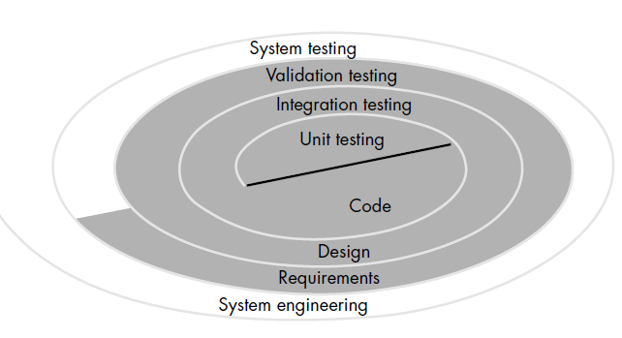

A strategy for software testing may also be viewed in the context of the spiral (Figure 18.1). Unit testing begins at the vortex of the spiral and concentrates on each unit (i.e., component) of the software as implemented in source code. Testing progresses by moving outward along the spiral to integration testing, where the focus is on design and the construction of the software architecture. Taking another turn outward on the spiral, we encounter validation testing, where requirements established as part of software requirements analysis are validated against the software that has been constructed. Finally, we arrive at system testing, where the software and other system elements are tested as a whole. To test computer software, we spiral out along streamlines that broaden the scope of testing with each turn.
Considering the process from a procedural point of view, testing within the context of software engineering is actually a series of four steps that are implemented sequentially. The steps are shown in Figure 18.2. Initially, tests focus on each component individually, ensuring that it functions properly as a unit. Hence, the name unit testing. Unit testing makes heavy use of white-box testing techniques, exercising specific paths in a module's control structure to ensure complete coverage and maximum error detection. Next, components must be assembled or integrated to form the complete software package. Integration testing addresses the issues associated with the dual problems of verification and program construction. Black-box test case design techniques are the most prevalent during integration, although a limited amount of white-box testing may be used to ensure coverage of major control paths. After the software has been integrated (constructed), a set of high-order tests are conducted. Validation criteria (established during requirements analysis) must be tested. Validation testing provides final assurance that software meets all functional, behavioral, and performance requirements. Black-box testing techniques are used exclusively during validation.
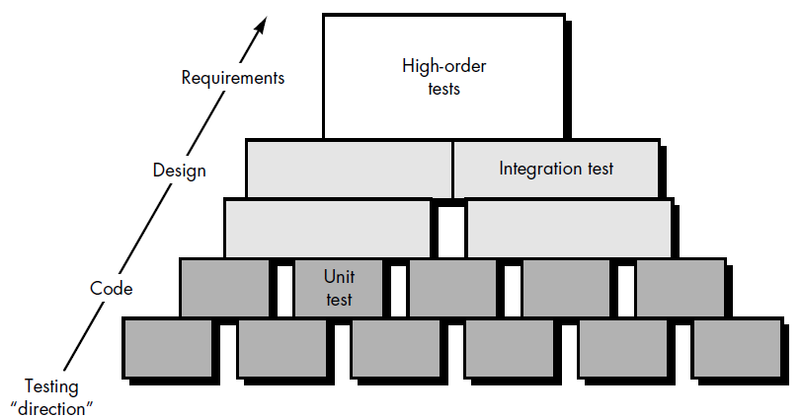

The last high-order testing step falls outside the boundary of software engineering and into the broader context of computer system engineering. Software, once validated, must be combined with other system elements (e.g., hardware, people, databases). System testing verifies that all elements mesh properly and that overall system function/performance is achieved.

2.2.1 Criteria for Completion of Testing
A classic question arises every time software testing is discussed: "When are we done testing—how do we know that we've tested enough?" Sadly, there is no definitive answer to this question, but there are a few pragmatic responses and early attempts at empirical guidance. One response to the question is: "You're never done testing, the burden simply shifts from you (the software engineer) to your customer." Every time the customer/ user executes a computer program, the program is being tested. This sobering fact underlines the importance of other software quality assurance activities. Another response (somewhat cynical but nonetheless accurate) is: "You're done testing when you run out of time or you run out of money."

Although few practitioners would argue with these responses, a software engineer needs more rigorous criteria for determining when sufficient testing has been conducted. Musa and Ackerman [MUS89] suggest a response that is based on statistical criteria: "No, we cannot be absolutely certain that the software will never fail, but relative to a theoretically sound and experimentally validated statistical model, we have done sufficient testing to say with 95 percent confidence that the probability of 1000 CPU hours of failure free operation in a probabilistically defined environment is at least 0.995."

2.2.2 VALIDATION TESTING
Testing Strategies: A strategic approach to software testing, test strategies for conventional software, Black-Box and White-Box testing, Validation testing, System testing, the art of Debugging.
2.2.2.1 Validation testing
At the culmination of integration testing, software is completely assembled as a package, interfacing errors have been uncovered and corrected, and a final series of software tests validation testing—may begin. Validation can be defined in many ways, but a simple (albeit harsh) definition is that validation succeeds when software functions in a manner that can be reasonably expected by the customer. At this point a battle-hardened software developer might protest: "Who or what is the arbiter of reasonable expectations?"
Reasonable expectations are defined in the Software Requirements Specification— a document that describes all user-visible attributes of the software. The specification contains a section called Validation Criteria. Information contained in that section forms the basis for a validation testing approach.
2.2.2.2 Validation Test Criteria
Software validation is achieved through a series of black-box tests that demonstrate conformity with requirements. A test plan outlines the classes of tests to be conducted and a test procedure defines specific test cases that will be used to demonstrate conformity with requirements. Both the plan and procedure are designed to ensure that all functional requirements are satisfied, all behavioral characteristics are achieved, all performance requirements are attained, documentation is correct, and human-engineered and other requirements are met (e.g., transportability, compatibility, error recovery, maintainability).
After each validation test case has been conducted, one of two possible conditions exist: (1) The function or performance characteristics conform to specification and are accepted or (2) a deviation from specification is uncovered and a deficiency list is created. Deviation or error discovered at this stage in a project can rarely be corrected prior to scheduled delivery. It is often necessary to negotiate with the customer to establish a method for resolving deficiencies.
2.2.2.3 Configuration Review
An important element of the validation process is a configuration review. The intent of the review is to ensure that all elements of the software configuration have been properly developed, are cataloged, and have the necessary detail to bolster the support phase of the software life cycle. The configuration review, sometimes called an audit, has been discussed in more detail in.

2.2.2.4 Alpha and Beta Testing
It is virtually impossible for a software developer to foresee how the customer will really use a program. Instructions for use may be misinterpreted; strange combinations of data may be regularly used; output that seemed clear to the tester may be unintelligible to a user in the field
When custom software is built for one customer, a series of acceptance tests are conducted to enable the customer to validate all requirements. Conducted by the end-user rather than software engineers, an acceptance test can range from an informal "test drive" to a planned and systematically executed series of tests. In fact, acceptance testing can be conducted over a period of weeks or months, thereby uncovering cumulative errors that might degrade the system over time.
If software is developed as a product to be used by many customers, it is impractical to perform formal acceptance tests with each one. Most software product builders use a process called alpha and beta testing to uncover errors that only the end-user seems able to find.
The alpha test is conducted at the developer's site by a customer. The software is used in a natural setting with the developer "looking over the shoulder" of the user and recording errors and usage problems. Alpha tests are conducted in a controlled environment.
The beta test is conducted at one or more customer sites by the end-user of the software. Unlike alpha testing, the developer is generally not present. Therefore, the beta test is a "live" application of the software in an environment that cannot be controlled by the developer. The customer records all problems (real or imagined) that are encountered during beta testing and reports these to the developer at regular intervals. As a result of problems reported during beta tests, software engineers make modifications and then prepare for release of the software product to the entire customer base

2.2.3 System Testing
At the beginning of this book, we stressed the fact that software is only one element of a larger computer-based system. Ultimately, software is incorporated with other system elements (e.g., hardware, people, information), and a series of system integration and validation tests are conducted. These tests fall outside the scope of the
software process and are not conducted solely by software engineers. However, steps taken during software design and testing can greatly improve the probability of successful software integration in the larger system.
A classic system testing problem is "finger-pointing." This occurs when an error is uncovered, and each system element developer blames the other for the problem. Rather than indulging in such nonsense, the software engineer should anticipate potential interfacing problems and (1) design error-handling paths that test all information coming from other elements of the system, (2) conduct a series of tests that simulate bad data or other potential errors at the software interface, (3) record the results of tests to use as "evidence" if finger-pointing does occur, and (4) participate in planning and design of system tests to ensure that software is adequately tested.
System testing is actually a series of different tests whose primary purpose is to fully exercise the computer-based system. Although each test has a different purpose, all work to verify that system elements have been properly integrated and perform allocated functions. In the sections that follow, we discuss the types of system tests [BEI84] that are worthwhile for software-based systems.

2.2.3.1 Recovery Testing
Many computer based systems must recover from faults and resume processing within a prespecified time. In some cases, a system must be fault tolerant; that is, processing faults must not cause overall system function to cease. In other cases, a system failure must be corrected within a specified period of time or severe economic damage will occur.
Recovery testing is a system test that forces the software to fail in a variety of ways and verifies that recovery is properly performed. If recovery is automatic (performed by the system itself), reinitialization, checkpointing mechanisms, data recovery, and restart are evaluated for correctness. If recovery requires human intervention, the mean-time-to-repair (MTTR) is evaluated to determine whether it is within acceptable limits.
2.2.3.2 Security Testing
Any computer-based system that manages sensitive information or causes actions that can improperly harm (or benefit) individuals is a target for improper or illegal penetration. Penetration spans a broad range of activities: hackers who attempt to penetrate systems for sport; disgruntled employees who attempt to penetrate for revenge; dishonest individuals who attempt to penetrate for illicit personal gain.
Security testing attempts to verify that protection mechanisms built into a system will, in fact, protect it from improper penetration. To quote Beizer [BEI84]: "The system's security must, of course, be tested for invulnerability from frontal attack—but must also be tested for invulnerability from flank or rear attack."
During security testing, the tester plays the role(s) of the individual who desires to penetrate the system. Anything goes! The tester may attempt to acquire passwords
through external clerical means; may attack the system with custom software designed to breakdown any defenses that have been constructed; may overwhelm the system, thereby denying service to others; may purposely cause system errors, hoping to penetrate during recovery; may browse through insecure data, hoping to find the key to system entry.
Given enough time and resources, good security testing will ultimately penetrate a system. The role of the system designer is to make penetration cost more than the value of the information that will be obtained.
2.2.3.3 Stress Testing
During earlier software testing steps, white-box and black-box techniques resulted in thorough evaluation of normal program functions and performance. Stress tests are designed to confront programs with abnormal situations. In essence, the tester who performs stress testing asks: "How high can we crank this up before it fails?"
Stress testingexecutes a system in a manner that demands resources in abnormal quantity, frequency, or volume. For example, (1) special tests may be designed that generate ten interrupts per second, when one or two is the average rate, (2) input data rates may be increased by an order of magnitude to determine how input functions will respond, (3) test cases that require maximum memory or other resources are executed, (4) test cases that may cause thrashing in a virtual operating system are designed, (5) test cases that may cause excessive hunting for disk-resident data are created. Essentially, the tester attempts to break the program.
A variation of stress testing is a technique called sensitivity testing. In some situations (the most common occur in mathematical algorithms), a very small range of data contained within the bounds of valid data for a program may cause extreme and even erroneous processing or profound performance degradation. Sensitivity testing attempts to uncover data combinations within valid input classes that may cause instability or improper processing.
2.2.3.4 Performance Testing
- For real-time and embedded systems, software that provides required function but does not conform to performance requirements is unacceptable. Performance testing is designed to test the run-time performance of software within the context of an integrated system. Performance testing occurs throughout all steps in the testing process. Even at the unit level, the performance of an individual module may be assessed as white-box tests are conducted. However, it is not until all system elements are fully integrated that the true performance of a system can be ascertained.
Performance tests are often coupled with stress testing and usually require both hardware and software instrumentation. That is, it is often necessary to measure resource utilization (e.g., processor cycles) in an exacting fashion. External instrum entation can monitor execution intervals, log events (e.g., interrupts) as they occur, and sample machine states on a regular basis. By instrumenting a system, the tester can uncover situations that lead to degradation and possible system failure.
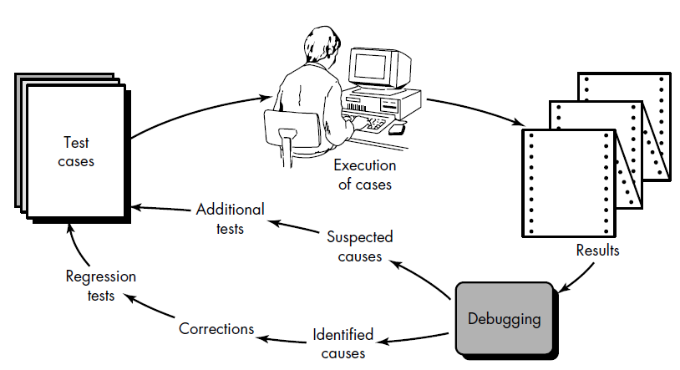

2.3 THE ART OF DEBUGGING
Software testing is a process that can be systematically planned and specified. Test case design can be conducted, a strategy can be defined, and results can be evaluated against prescribed expectations
Debugging occurs as a consequence of successful testing. That is, when a test case uncovers an error, debugging is the process that results in the removal of the error. Although debugging can and should be an orderly process, it is still very much an art. A software engineer, evaluating the results of a test, is often confronted with a "symptomatic" indication of a software problem. That is, the external manifestation of the error and the internal cause of the error may have no obvious relationship to one another. The poorly understood mental process that connects a symptom to a cause is debugging.
2.3.1 The Debugging Process
Debugging is not testing but always occurs as a consequence of testing.⁴ Referring to Figure 18.8, the debugging process begins with the execution of a test case. Results are assessed and a lack of correspondence between expected and actual performance is encountered. In many cases, the noncorresponding data are a symptom
of an underlying cause as yet hidden. The debugging process attempts to match symptom with cause, thereby leading to error correction.
The debugging process will always have one of two outcomes: (1) the cause will be found and corrected, or (2) the cause will not be found. In the latter case, the person performing debugging may suspect a cause, design a test case to help validate that suspicion, and work toward error correction in an iterative fashion.
Why is debugging so difficult? In all likelihood, human psychology (see the next section) has more to do with an answer than software technology. However, a few characteristics of bugs provide some clues:
- The symptom and the cause may be geographically remote. That is, the symptom may appear in one part of a program, while the cause may actually be located at a site that is far removed. Highly coupled program structures (Chapter 13) exacerbate this situation.
- The symptom may disappear (temporarily) when another error is corrected.
- The symptom may actually be caused by nonerrors (e.g., round-off inaccuracies).
- The symptom may be caused by human error that is not easily traced.
- The symptom may be a result of timing problems, rather than processing problems.
- It may be difficult to accurately reproduce input conditions (e.g., a real-time application in which input ordering is indeterminate).
- The symptom may be intermittent. This is particularly common in embedded systems that couple hardware and software inextricably.
- The symptom may be due to causes that are distributed across a number of tasks running on different processors [CHE90].
During debugging, we encounter errors that range from mildly annoying (e.g., an incorrect output format) to catastrophic (e.g. the system fails, causing serious economic or physical damage). As the consequences of an error increase, the amount of pressure to find the cause also increases. Often, pressure sometimes forces a software developer to fix one error and at the same time introduce two more.

2.3.2 Psychological Considerations
Unfortunately, there appears to be some evidence that debugging prowess is an innate human trait. Some people are good at it and others aren't. Although experimental evidence on debugging is open to many interpretations, large variances in debugging ability have been reported for programmers with the same education and experience.
Commenting on the human aspects of debugging, Shneiderman [SHN80] states:
Debugging is one of the more frustrating parts of programming. It has elements of problem solving or brain teasers, coupled with the annoying recognition that you have made a mistake. Heightened anxiety and the unwillingness to accept the possibility of errors increases the task difficulty. Fortunately, there is a great sigh of relief and a lessening of tension when the bug is ultimately . . . corrected.
Although it may be difficult to "learn" debugging, a number of approaches to the problem can be proposed. We examine these in the next section.

2.3.3 Debugging Approaches
Regardless of the approach that is taken, debugging has one overriding objective: to find and correct the cause of a software error. The objective is realized by a combination of systematic evaluation, intuition, and luck. Bradley [BRA85] describes the debugging approach in this way:
Debugging is a straightforward application of the scientific method that has been developed over 2,500 years. The basis of debugging is to locate the problem's source [the cause] by binary partitioning, through working hypotheses that predict new values to be examined.
Take a simple non-software example: A lamp in my house does not work. If nothing in the house works, the cause must be in the main circuit breaker or outside; I look around to see whether the neighborhood is blacked out. I plug the suspect lamp into a working socket and a working appliance into the suspect circuit. So goes the alternation of hypothesis and
test.
In general, three categories for debugging approaches may be proposed [MYE79]: (1) brute force, (2) backtracking, and (3) cause elimination.
The brute force category of debugging is probably the most common and least efficient method for isolating the cause of a software error. We apply brute force debugging methods when all else fails. Using a "let the computer find the error" philosophy, memory dumps are taken, run-time traces are invoked, and the program is loaded with WRITE statements. We hope that somewhere in the morass of information that is produced we will find a clue that can lead us to the cause of an error. Although the mass of information produced may ultimately lead to success, it more frequently leads to wasted effort and time. Thought must be expended first!
Backtracking is a fairly common debugging approach that can be used successfully in small programs. Beginning at the site where a symptom has been uncovered, the source code is traced backward (manually) until the site of the cause is found. Unfortunately, as the number of source lines increases, the number of potential backward paths may become unmanageably large.
The third approach to debugging—cause elimination—is manifested by induction or deduction and introduces the concept of binary partitioning. Data related to the error occurrence are organized to isolate potential causes. A "cause hypothesis" is
devised and the aforementioned data are used to prove or disprove the hypothesis. Alternatively, a list of all possible causes is developed and tests are conducted to eliminate each. If initial tests indicate that a particular cause hypothesis shows promise, data are refined in an attempt to isolate the bug.
Each of these debugging approaches can be supplemented with debugging tools. We can apply a wide variety of debugging compilers, dynamic debugging aids ("tracers"), automatic test case generators, memory dumps, and cross-reference maps. However, tools are not a substitute for careful evaluation based on a complete software design document and clear source code.
Any discussion of debugging approaches and tools is incomplete without mention of a powerful ally—other people! Each of us can recall puzzling for hours or days over a persistent bug. A colleague wanders by and in desperation we explain the problem and throw open the listing. Instantaneously (it seems), the cause of the error is uncovered. Smiling smugly, our colleague wanders off. A fresh viewpoint, unclouded by hours of frustration, can do wonders. A final maxim for debugging might be: "When all else fails, get help!"
Once a bug has been found, it must be corrected. But, as we have already noted, the correction of a bug can introduce other errors and therefore do more harm than good. Van Vleck [VAN89] suggests three simple questions that every software engineer should ask before making the "correction" that removes the cause of a bug:
- Is the cause of the bug reproduced in another part of the program?
In many situations, a program defect is caused by an erroneous pattern of logic that may be reproduced elsewhere. Explicit consideration of the logical pattern may result in the discovery of other errors.
- What "next bug" might be introduced by the fix I'm about to make?
Before the correction is made, the source code (or, better, the design) should be evaluated to assess coupling of logic and data structures. If the correction is to be made in a highly coupled section of the program, special care must be taken when any change is made.
What could we have done to prevent this bug in the first place? This question is the first step toward establishing a statistical software quality assurance approach. If we correct the process as well as the product, the bug will be removed from the current program and may be eliminated from all future programs.
2.3.4 White Box Testing:
White-box testing, sometimes called glass-box testing, is a test case design method that uses the control structure of the procedural design to derive test cases. Using white-box testing methods, the software engineer can derive test cases that (1) guarantee that all independent paths within a module have been exercised at least once, (2) exercise all logical decisions on their true and false sides, (3) execute all loops at their boundaries and within their operational bounds, and (4) exercise internal data structures to ensure their validity.
A reasonable question might be posed at this juncture: "Why spend time and energy worrying about (and testing) logical minutiae when we might better expend effort ensuring that program requirements have been met?" Stated another way, why don't we spend all of our energy on black-box tests? The answer lies in the nature of software defects (e.g., [JON81]):
- Logic errors and incorrect assumptions are inversely proportional to the probability that a program path will be executed. Errors tend to creep into our work when we design and implement function, conditions, or control that are out of the mainstream. Everyday processing tends to be well understood (and well scrutinized), while "special case" processing tends to fall into the cracks.
- We often believe that a logical path is not likely to be executed when, in fact, it may be executed on a regular basis. The logical flow of a program is sometimes counterintuitive, meaning that our unconscious assumptions about flow of control and data may lead us to make design errors that are uncovered only once path testing commences.
- Typographical errors are random. When a program is translated into programming language source code, it is likely that some typing errors will occur. Many will be uncovered by syntax and type checking mechanisms, but others may go undetected until testing begins. It is as likely that a typo will exist on an obscure logical path as on a mainstream path.
- Each of these reasons provides an argument for conducting white-box tests. Black-box testing, no matter how thorough, may miss the kinds of errors noted here. White-box testing is far more likely to uncover them.
2.3.5 Black Box Testing:
Black-box testing, also called behavioral testing, focuses on the functional requirements of the software. That is, black-box testing enables the software engineer to derive sets of input conditions that will fully exercise all functional requirements for a program. Black-box testing is not an alternative to white-box techniques. Rather, it is a complementary approach that is likely to uncover a different class of errors than white-box methods.
Black-box testing attempts to find errors in the following categories: (1) incorrect or missing functions, (2) interface errors, (3) errors in data structures or external data base access, (4) behavior or performance errors, and (5) initialization and termination errors.
Unlike white-box testing, which is performed early in the testing process, black-box testing tends to be applied during later stages of testing (see Chapter 18). Because black-box testing purposely disregards control structure, attention is focused on the information domain. Tests are designed to answer the following questions:
- How is functional validity tested?
- How is system behavior and performance tested?
- What classes of input will make good test cases?
- Is the system particularly sensitive to certain input values?
- How are the boundaries of a data class isolated?
- What data rates and data volume can the system tolerate?
- What effect will specific combinations of data have on system operation?
By applying black-box techniques, we derive a set of test cases that satisfy the following criteria [MYE79]: (1) test cases that reduce, by a count that is greater than one, the number of additional test cases that must be designed to achieve reasonable testing and (2) test cases that tell us something about the presence or absence of classes of errors, rather than an error associated only with the specific test at hand.
Graph-Based Testing Methods
The first step in black-box testing is to understand the objects⁶ that are modeled in software and the relationships that connect these objects. Once this has been accomplished, the next step is to define a series of tests that verify "all objects have the expected relationship to one another [BEI95]." Stated in another way, software testing begins by creating a graph of important objects and their relationships and then devising a series of tests that will cover the graph so that each object and relationship is exercised and errors are uncovered.
To accomplish these steps, the software engineer begins by creating a graph—a collection of nodes that represent objects; links that represent the relationships between objects; node weights that describe the properties of a node (e.g., a specific data value or state behavior); and link weights that describe some characteristic of a link.
The symbolic representation of a graph is shown in Figure . Nodes are represented as circles connected by links that take a number of different forms. A directed link (represented by an arrow) indicates that a relationship moves in only one direction. A bidirectional link, also called a symmetric link, implies that the relationship applies in both directions. Parallel links are used when a number of different relationships are established between graph nodes.
As a simple example, consider a portion of a graph for a word-processing application where
Object #1 = new file menu select Object #2 = document window Object #3 = document text Referring to the figure, a menu select on new file generates a document window. The node weight of document window provides a list of the window attributes that are to be expected when the window is generated. The link weight indicates that the window must be generated in less than 1.0 second. An undirected link establishes a symmetric relationship between the new file menu select and document text, and parallel links indicate relationships between document window and document text. In reality, a far more detailed graph would have to be generated as a precursor to test case design. The software engineer then derives test cases by traversing the graph and covering each of the relationships shown. These test cases are designed in an attempt to find errors in any of the relationships.
Beizer [BEI95] describes a number of behavioral testing methods that can make use of graphs:

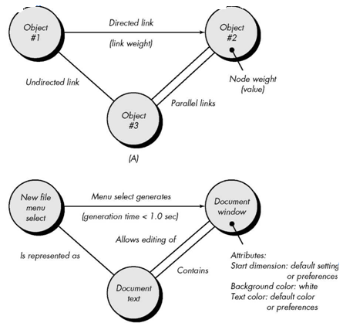

Transaction flow modeling. The nodes represent steps in some transaction (e.g., the steps required to make an airline reservation using an on-line service), and the links represent the logical connection between steps (e.g., flight.information.input is followed by validation/availability.processing). The data flow diagram (Chapter 12) can be used to assist in creating graphs of this type.
Finite state modeling. The nodes represent different user observable states of the software (e.g., each of the "screens" that appear as an order entry clerk takes a phone order), and the links represent the transitions that occur to move from state to state (e.g., order-information is verified during inventory-availability look-up and is followed by customer-billing-information input). The state transition diagram (Chapter 12) can be used to assist in creating graphs of this type.
Data flow modeling. The nodes are data objects and the links are the transformations that occur to translate one data object into another. For example, the node FICA.tax.withheld (FTW) is computed from gross.wages (GW) using the relationship, FTW = 0.62 x GW.
Timing modeling. The nodes are program objects and the links are the sequential connections between those objects. Link weights are used to specify the required execution times as the program executes.

Equivalence Partitioning
Equivalence partitioning is a black-box testing method that divides the input domain of a program into classes of data from which test cases can be derived. An ideal test case single-handedly uncovers a class of errors (e.g., incorrect processing of all character data) that might otherwise require many cases to be executed before the general error is observed. Equivalence partitioning strives to define a test case that uncovers classes of errors, thereby reducing the total number of test cases that must be developed.
Test case design for equivalence partitioning is based on an evaluation of equivalence classes for an input condition. Using concepts introduced in the preceding section, if a set of objects can be linked by relationships that are symmetric, transitive, and reflexive, an equivalence class is present [BEI95]. An equivalence class represents a set of valid or invalid states for input conditions. Typically, an input condition is either a specific numeric value, a range of values, a set of related values, or a Boolean condition. Equivalence classes may be defined according to the following guidelines:
- If an input condition specifies a range, one valid and two invalid equivalence classes are defined.
- If an input condition requires a specific value, one valid and two invalid equivalence classes are defined.
- If an input condition specifies a member of a set, one valid and one invalid equivalence class are defined.
- If an input condition is Boolean, one valid and one invalid class are defined.
As an example, consider data maintained as part of an automated banking application. The user can access the bank using a personal computer, provide a six-digit password, and follow with a series of typed commands that trigger various banking functions. During the log-on sequence, the software supplied for the banking application accepts data in the form
area code—blank or three-digit number
prefix—three-digit number not beginning with 0 or 1
suffix—four-digit number
password—six digit alphanumeric string
commands—check, deposit, bill pay, and the like
The input conditions associated with each data element for the banking application can be specified as area code: Input condition, Boolean—the area code may or may not be present.
Input condition, range—values defined between 200 and 999, with
specific exceptions. prefix: Input condition, range—specified value >200
Input condition, value—four-digit length password: Input condition, Boolean—a password may or may not be present.
Input condition, value—six-character string. command: Input condition, set—containing commands noted previously.
Applying the guidelines for the derivation of equivalence classes, test cases for each input domain data item can be developed and executed. Test cases are selected so that the largest number of attributes of an equivalence class are exercised at once.

Boundary Value Analysis
For reasons that are not completely clear, a greater number of errors tends to occur at the boundaries of the input domain rather than in the "center." It is for this reason that boundary value analysis (BVA) has been developed as a testing technique. Boundary value analysis leads to a selection of test cases that exercise bounding values.
Boundary value analysis is a test case design technique that complements equivalence partitioning. Rather than selecting any element of an equivalence class, BVA leads to the selection of test cases at the "edges" of the class. Rather than focusing solely on input conditions, BVA derives test cases from the output domain as well [MYE79].
Guidelines for BVA are similar in many respects to those provided for equivalence partitioning:
- If an input condition specifies a range bounded by values a and b, test cases should be designed with values a and b and just above and just below a and b.
- If an input condition specifies a number of values, test cases should be developed that exercise the minimum and maximum numbers. Values just above and below minimum and maximum are also tested.
- Apply guidelines 1 and 2 to output conditions. For example, assume that a temperature vs. pressure table is required as output from an engineering analysis program. Test cases should be designed to create an output report that produces the maximum (and minimum) allowable number of table entries.
- If internal program data structures have prescribed boundaries (e.g., an array has a defined limit of 100 entries), be certain to design a test case to exercise the data structure at its boundary.
Most software engineers intuitively perform BVA to some degree. By applying these guidelines, boundary testing will be more complete, thereby having a higher likelihood for error detection.
Comparison Testing
There are some situations (e.g., aircraft avionics, automobile braking systems) in which the reliability of software is absolutely critical. In such applications redundant hardware and software are often used to minimize the possibility of error. When redundant software is developed, separate software engineering teams develop independent versions of an application using the same specification. In such situations, each version can be tested with the same test data to ensure that all provide identical output. Then all versions are executed in parallel with real-time comparison of results to ensure consistency.
Using lessons learned from redundant systems, researchers (e.g., [BRI87]) have suggested that independent versions of software be developed for critical applications, even when only a single version will be used in the delivered computer-based system. These independent versions form the basis of a black-box testing technique called comparison testing or back-to-back testing [KNI89].
When multiple implementations of the same specification have been produced, test cases designed using other black-box techniques (e.g., equivalence partitioning) are provided as input to each version of the software. If the output from each version is the same, it is assumed that all implementations are correct. If the output is different, each of the applications is investigated to determine if a defect in one or more versions is responsible for the difference. In most cases, the comparison of outputs can be performed by an automated tool.
Comparison testing is not foolproof. If the specification from which all versions have been developed is in error, all versions will likely reflect the error. In addition, if each of the independent versions produces identical but incorrect results, condition testing will fail to detect the error.

Orthogonal Array Testing
There are many applications in which the input domain is relatively limited. That is, the number of input parameters is small and the values that each of the parameters may take are clearly bounded. When these numbers are very small (e.g., three input parameters taking on three discrete values each), it is possible to consider every input permutation and exhaustively test processing of the input domain. However, as the number of input values grows and the number of discrete values for each data item increases, exhaustive testing become impractical or impossible.
Orthogonal array testing can be applied to problems in which the input domain is relatively small but too large to accommodate exhaustive testing. The orthogonal array testing method is particularly useful in finding errors associated with region faults—an error category associated with faulty logic within a software component.

